**Lab 4**:

**Prims program for finding minimal spamming tree**

#include <stdio.h>

#include <limits.h>

#include <stdbool.h>

#define MAX 100

int findMinKey(int key[], bool mstSet[], int n) {

int min = INT_MAX, min_index = -1;

for (int v = 0; v < n; v++) {

if (!mstSet[v] && key[v] < min) {

min = key[v];

min_index = v;

}

}

return min_index;

}

void primMST(int graph[MAX][MAX], int n, int start) {

int parent[MAX];

int key[MAX];

bool mstSet[MAX];

for (int i = 0; i < n; i++) {

key[i] = INT_MAX;

mstSet[i] = false;

}

key[start] = 0;

parent[start] = -1;

for (int count = 0; count < n - 1; count++) {

int u = findMinKey(key, mstSet, n);

mstSet[u] = true;

for (int v = 0; v < n; v++) {

if (graph[u][v] && !mstSet[v] && graph[u][v] < key[v]) {

parent[v] = u;

key[v] = graph[u][v];

}

}

}

int totalWeight = 0;

printf("\nMinimum Spanning Tree Edges:\n");

for (int i = 0; i < n; i++) {

if (i != start && parent[i] != -1) {

printf("%d - %d (weight %d)\n", parent[i], i, graph[i][parent[i]]);

totalWeight += graph[i][parent[i]];

}

}

printf("Total weight of MST: %d\n", totalWeight);

}

int main() {

int n, m, start;

int graph[MAX][MAX] = {0};

printf("Enter number of vertices and edges: ");

scanf("%d %d", &n, &m);

printf("Enter %d edges (u v weight):\n", m);

for (int i = 0; i < m; i++) {

int u, v, w;

scanf("%d %d %d", &u, &v, &w);

graph[u][v] = w;

graph[v][u] = w;

}

printf("Enter the starting vertex (0 to %d): ", n - 1);

scanf("%d", &start);

if (start < 0 || start >= n) {

printf("Invalid start vertex!\n");

return 1;

}

primMST(graph, n, start);

return 0;

}

Output:

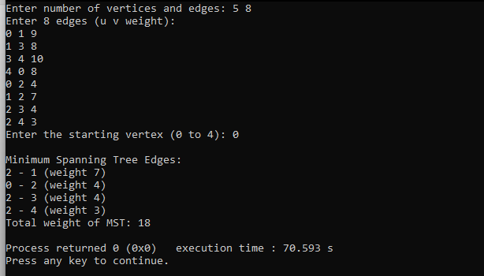

**2. Kruskal’s Algorithm**

#include <stdio.h>  
#include <stdlib.h>  
  
#define MAX 100  
#define INF 9999  
  
int parent[MAX];  
  
int find(int i) {  
while (parent[i] != i)  
i = parent[i];  
return i;  
}  
  
void union_set(int i, int j) {  
int a = find(i);  
int b = find(j);  
parent[a] = b;  
}  
  
int main() {  
int n;  
int cost[MAX][MAX];  
int i, j, a, b, u, v;  
int ne = 0, mincost = 0, min;  
  
printf("Enter number of vertices: ");  
scanf("%d", &n);  
  
printf("Enter the adjacency matrix (0 if no edge):\n");  
for (i = 0; i < n; i++) {  
for (j = 0; j < n; j++) {  
scanf("%d", &cost[i][j]);  
if (cost[i][j] == 0)  
cost[i][j] = INF;  
}  
}  
  
for (i = 0; i < n; i++)  
parent[i] = i;  
  
printf("Edge \tWeight\n");  
while (ne < n - 1) {  
min = INF;  
for (i = 0; i < n; i++) {  
for (j = 0; j < n; j++) {  
if (find(i) != find(j) && cost[i][j] < min) {  
min = cost[i][j];  
a = u = i;  
b = v = j;  
}  
}  
}  
  
union_set(u, v);  
printf("%d - %d\t%d\n", a, b, min);  
mincost += min;  
ne++;  
}  
  
printf("Minimum cost = %d\n", mincost);  
return 0;  
}

Output:

